Bolt Design :

Material : High speed steel

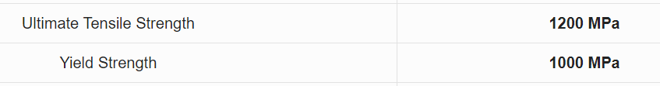

Stress = 0.5 (ultimate tensile strength)

= 0.5 x (1200) = 600 Mpa

Stress = Net force acting on the bolt / (cross sectional area)

Net force acting = sqrt(x component force^2 + y component force^2)

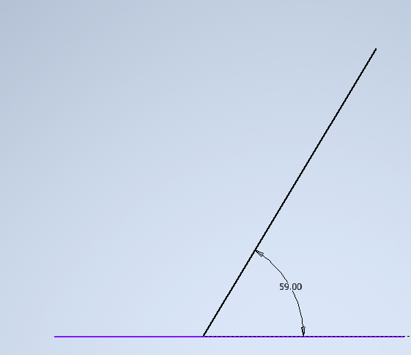

X axis net force = 4452.538 N + 6653.739 \* cos(59) (from wishbone calculation)

= 7879.466 N

Yaxis net force = 6653.739 \* sin(59)

= 5703.367 N

Total force = sqrt (x axis net force ^2 + y axis net force ^2 )

= 9727.149 N

Stress = force / area where , area = (pi/4) \* (diameter^2)

600 = 9727.149/(area)

Area = 16.93 mm^2

From which we get ,

Diameter of bolt = 4.64 mm

Length of bolt = 30 mm (6 times the diameter)